视 像 再 造
Remaking Our Vision
Traveling Exhibition on Chinese Contemporary Photography
——中国当代摄影国际巡回展
前 言

中国当代摄影在近几年迅速崛起，受到社会各界的普遍关注，成为解读中国当代艺术发展历程的重要艺术门类之一。
中国当代摄影的发展首先源自中国在近三十年来的巨大社会变革，中国的社会结构转型和文化意识也因社会变革而被再造。中国艺术家思考世界、观看现实的方式和态度也因时代之变而受到影响，同样地，中国艺术家也开始应用或借助于摄影的方式来创作他们认识中国、思考中国和表现中国的影像艺术。
中国艺术家对中国现实抱有深切的关注，也尝试了许多新的艺术观念表达方法，这就使得他们的影像创作与实践从一开始就不同于传统摄影所追求的目标，即镜头前的真实性和摄影语言的纯粹性，而是将摄影作为媒介、作为观念实验的手段来反映他们的思想、观念和立场。从这些当代的中国摄影中，可以看出中国艺术家在近几十年中的价值追求和艺术态度。他们从多个角度去见证开放中的中国、转型中的中国、历史文化遗产中的中国以及走向新时代的中国；他们不仅仅是去记录如是中国，而是以艺术家的个体精神和独立视角来想象、来创造现实境遇中的中国，也在个体观念的传递中去分析、解构中国历史文化在全球化网络中的关系。这里既有城市化扩展运动的视觉实证，也有社会心理激烈动荡的个体经验；也有思考艺术存在意义的探索，还有拓展摄影表现潜力的数字化艺术实验。
正因为这一切，中国的当代摄影成为最具活力、创造力的艺术形式之一，充分显示出艺术家的学习能力、创造能力和反思能力，而这些又都是当代社会对艺术价值与意义所诉求的。当中国变化如是之快时、当中国日益国际化和全球化之际时，影像语言就极其迅速地捕获了时代快节奏的韵律，也敏锐地再现了图像纪元到来的新景观。由于艺术的存在，使我们更加接近现实的真实，也更加理解中国现实的复杂性和多元性，同时又反映着中国面对的巨大挑战。“视像再造” 中国当代摄影展即意味着多元文化的交流和多样艺术的互动，让一个充满创造力的中国走近我们。

Foreword

Chinese contemporary photography has witnessed fast development and drawn extensive interest worldwide in recent years, emerging as an important art expression for the study of the evolution of Chinese contemporary art.

Chinese contemporary photography develops in the context of tremendous social transformation over the past three decades. China’s social structure and cultural identity have been reshaped as the result of the social reform that has been taking place throughout the whole country. Meanwhile, approaches and attitudes with which Chinese artists observe the world and realities have also changed along with the time. They have begun to make photographic creations as ways to observe, understand and demonstrate China.

Chinese contemporary artists show deep concerns over social realities of China and have tried many innovative ways to express their art concepts. Their goals in image creations and practices, from the very beginning, are fundamentally different from what traditional photography pursues, that is, authenticity in camera image and purity in photographic language. Instead, they use photography as a kind of media or an instrument of conceptual experiment to reflect their ideas, concepts and positions. From these photographic works on display, we can learn about Chinese artists’ pursuits of values and attitudes toward art over the past decades. They attempt to, from multi perspectives, record China’s opening and transition process, her historical and cultural traditions and her development in the new era. They do not merely chronicle China on film, but more importantly, imagine and create a realistic China with a spirit of individuality and an independent perspective as an artist. While expressing their individual concepts, they try to analyze and de-structure Chinese history and culture in the context of globalization. These image works epitomize visual witnesses of urbanized expansion movement, individual experiences of turbulence of social mentality, reflections on the significance of the existence of art, and digital art experiments on expanding potential of photographic expression.

Because of all those, Chinese contemporary photography has emerged as one of the most dynamic and creative forms of art expression, fully demonstrating artists’ abilities to learn, create and reflect. What they have created and pursued represents what the contemporary society seeks from values and meanings of art. In the context that China is developing rapidly and becomes increasingly globalized and internationalized, image artists have caught pulses of the time and present a new panorama of the image era. Art provides us possibilities to approach the truth of reality and understand complexity and diversity of Chinese realities, while reflecting tremendous changes that China is faced with. The exhibition “Remaking Our Vision” offers viewers an excellent opportunity to experience interactions of diversified cultures and arts and approach a creative China.

第一部分 观念纪实
Section I: Conceptual Documentary

当代摄影中的纪实影像明显地不同于传统纪实，其最大的差异在于观念纪实不是单纯记录被拍摄的对象，而是将拍摄主体——艺术家的观念融入到拍摄中，让被拍摄的人物、环境隐含了某种意义，这种摄影表面上客观、冷静，但经过了艺术家的自觉选择和精心拍摄，力图让对象说话，说出中国社会语境中的变化和故事。
缪晓春的《城中城》用宏大的场面再现了中国城市化的规模和热闹，背后是中国的快速时间和社会急剧变化；罗永进的“新民居”系列见证了一种新的怪诞的建筑意识，凸显了中国社会经济发展带来的文化矛盾；韩磊的《日常状态》将镜头指向生存在不同境遇中的中国人，诉说着寻常百姓的生命状态；

Documentary images of Chinese contemporary photography are notably different from traditional ones. The biggest difference is that conceptual documentary works not only record photographed objects; the artists who create images integrate their concepts into images so as to make images more meaningful. Photographic works created in this way seems to be an objective expression of facts, but has actually undergone conscious selection and elaboration by artists who aim to demonstrate changes and happenings taking place in the context of Chinese society.

The City in the City series, created by Miao Xiaochun, records the scale and vitality of China’s urbanization process and reflects drastic changes of Chinese society. The New Residence series, created by Luo Yongjin, demonstrates a weird type of architectural awareness and highlights cultural contradictions brought about by social and economic development of China. Everydayness, created by Han Lei, focuses on life states of ordinary Chinese living in different conditions.

- 缪晓春——《新都市现实》系列
New Urban Reallty series, by Miao Xiaochun
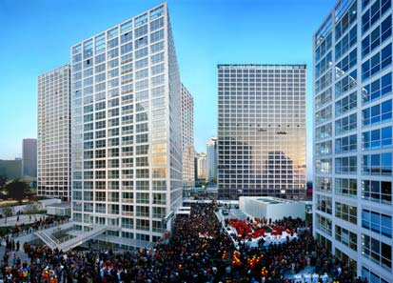
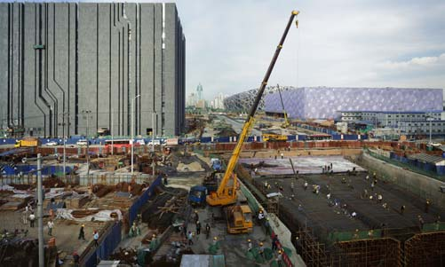
《新都市现实》在纪实的镜头里折射了中国城市化运动和宏大场面，也是现代化梦想的一种注解。
New Urban Reallty series record the great scene of the urbanization of China. These photos reflect our dream of modernization.

2、罗永进——《新民居杭州》
The New Residence in Hangzhou, by Luo Yongjin
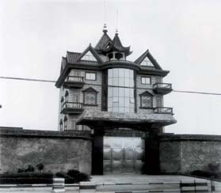
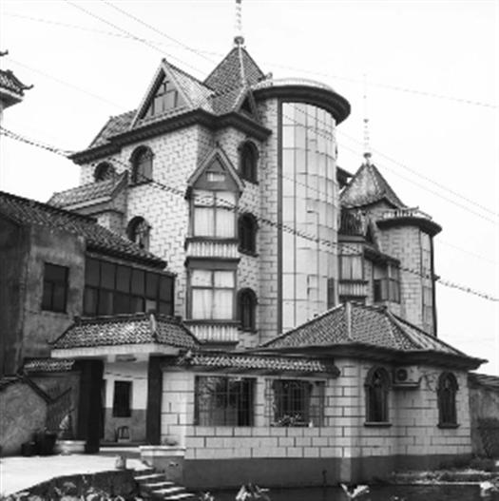

《新民居》系列记录了一种异样的建筑景观，仿佛这就是幸福生活的真实理解。
The New Residence series show an unusual architectural landscape, as if it represented a true interpretation of happy life.
- 韩磊——《日常状态》
The Everydayness, by Han Lei

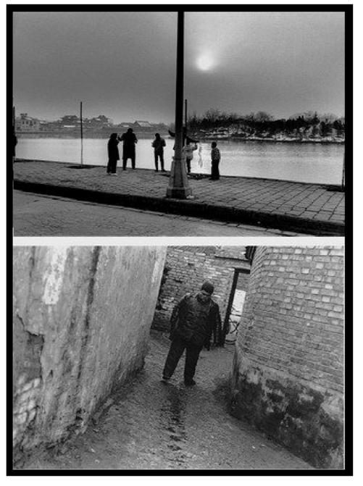
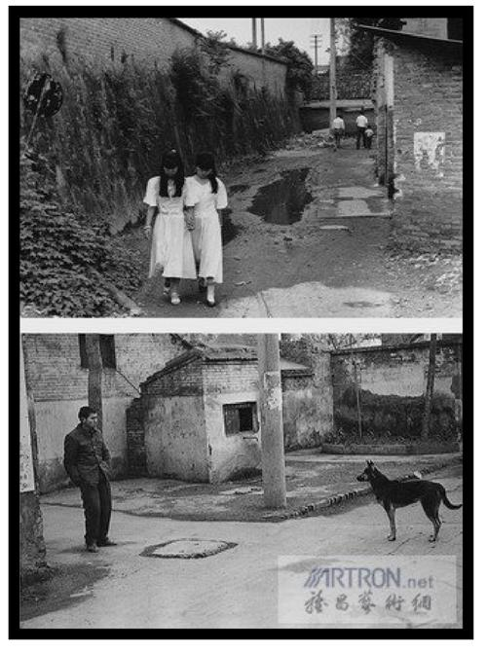

《日常状态》记录了形形色色的普通中国人的生活面貌，在这种纪实中让我们看到最民间的生活故事。
The Everydayness series record lives of ordinary Chinese people and document their truest facets of daily life.

第二部分 影像叙事
Section II Photographic Narration

当代摄影致力于探索与摄影相关的真实性的概念和界限，积极地构建一种主观的叙事情节，让摄影成为艺术家创造艺术的一种方法，从而产生新的视觉形式和视觉认知。于是，从摄影诞生之日起即存在的摆拍摄影也就自然而然地成为当代摄影中的重要手段。摆拍对“现实”的介入完全解构了传统摄影与视觉现实的关系，使摄影成为直接构建而非记录现实的主观表达手段。

Chinese contemporary photography aims to explore concepts and limits of authenticity pertaining to photography and tries to create subjective narrations in an active manner, hoping that photography may become a way that artists create art and thus new visual forms and cognition may be developed. Therefore, posing for photography, existing since the invention of photo technology, has been naturally an important approach in contemporary photography. The intervention into “reality” by posing thoroughly deconstructs the relationship between traditional photography and visual reality and thus photography has become a means of subjective expression to create reality, instead of to record reality.

4、王庆松——《跟我学》和《摆战场》
FOLLOW ME and The Installation of the Battlefield, by Wang Qingsong
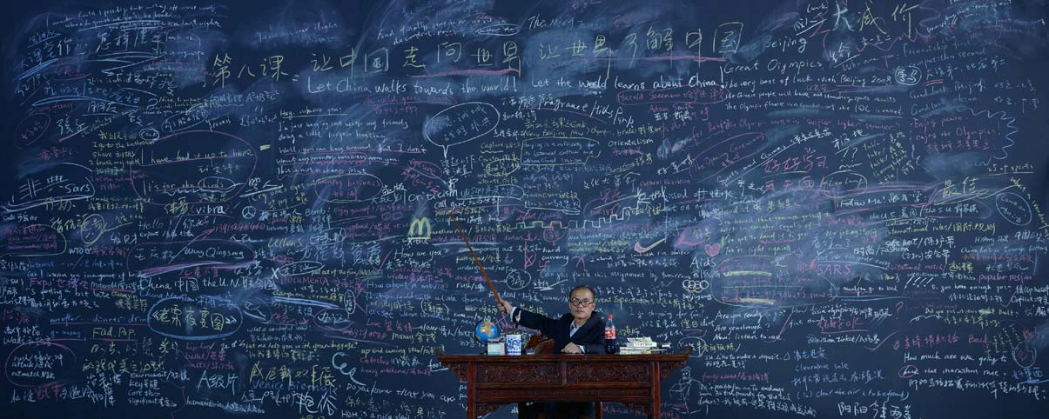

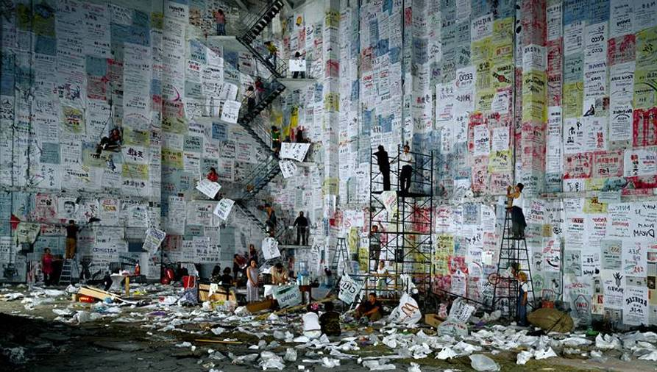

王庆松的《跟我学》是中国进行现代化梦想的开始，始于对国外新知的学习；《摆战场》则象征了商业化的中国景观。

The FOLLOW ME reflects China’s modernization drive which began by learning new knowledge from Western countries. The Installation of the Battlefield depicts the landscape of commercialized China.

5、邢丹文——《都市演绎》
Urban fiction, by Xing Danwei
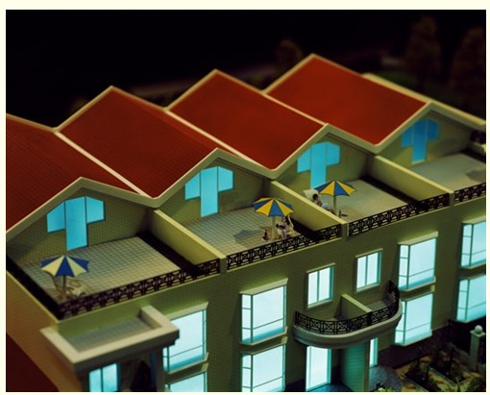
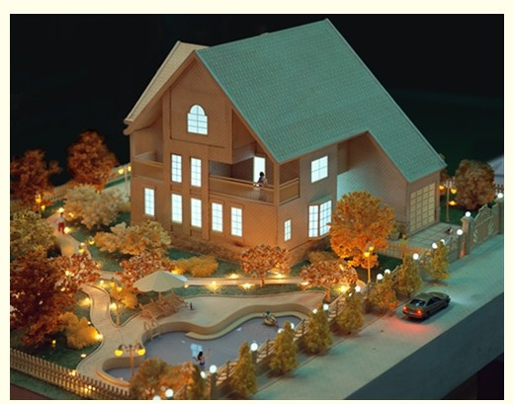

《都市演绎》是中国现代城市里的故事，演绎着一种中国之梦。
Urban fictions tells tories happening in modern cities of China and symbolizes Chinese dreams.

6、陈绍雄——《街道》
The Streets, by Chen Shaoxiong

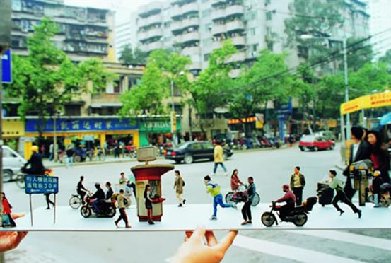
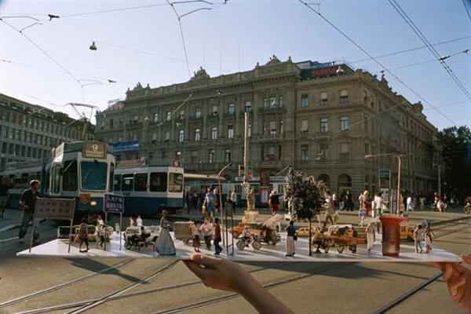

《街道》是城市空间与人的活动的关系。
The Streets series show the relationship between the urban space and the citizens.

7、张大力——《故宫》、《拆》

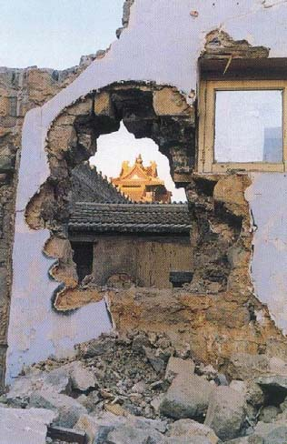
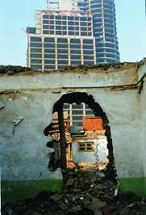

《故宫》 《拆》
The Forbidden City, by Zhang Dali Housing Demolition, by Zhang Dali

作品用残破的人物轮廓来反衬着城市的消失与重建的无奈。
The dilapidated figure reflects a helpless mentality when faced with the disappearance and reconstruction of the city.

8、蒋志——《彩虹》、《不在服务区的彩虹》
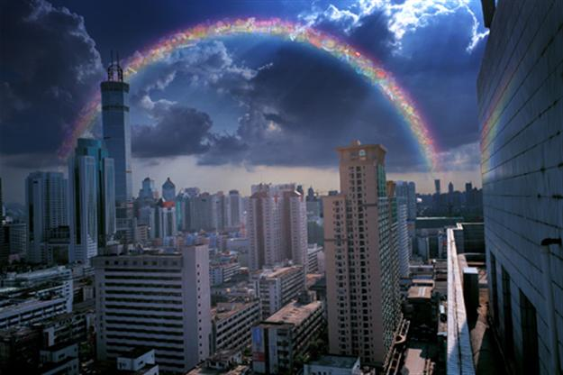
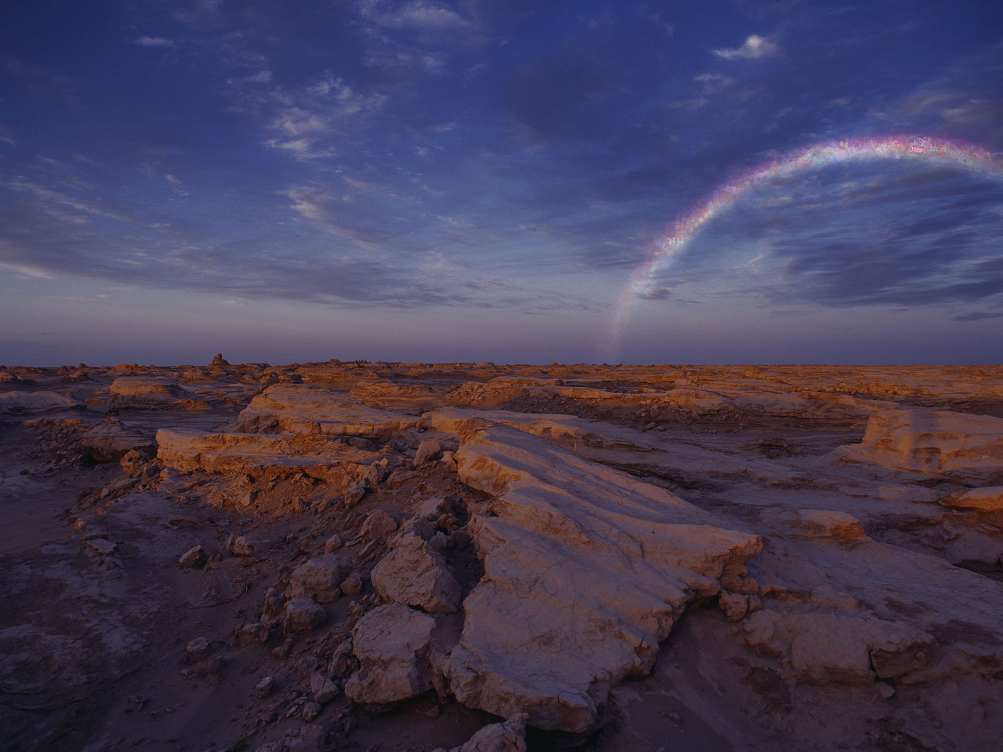

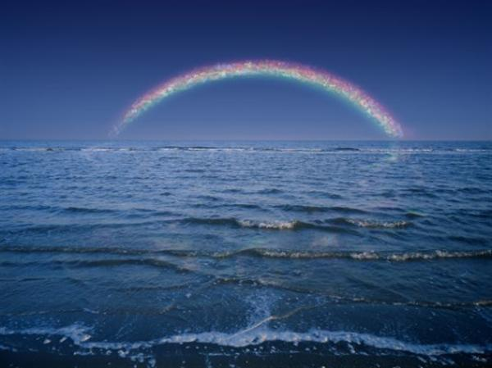
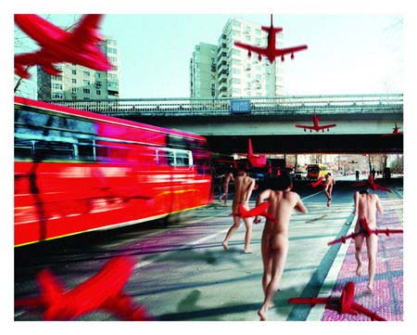
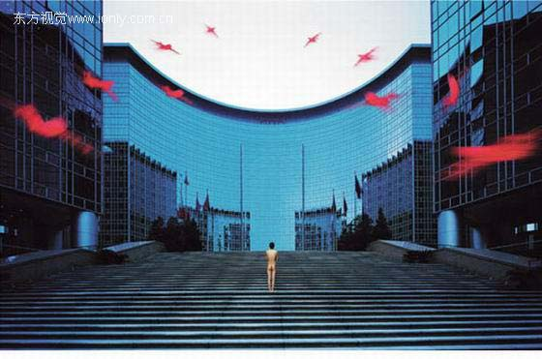
《彩虹》 《不在服务区的彩虹》
The Rainbow, by Jiang Zhi The Rainbow beyond the Service Area, by Jiang Zhi

作品将城市喻指为海市蜃楼般的灿烂。
In these works, the city looks so fascinating as if it were a mirage.

9、迟鹏——《奔》系列
The Run, by Chi Peng

作品《奔》凸显了人在城市中的脆弱和漂浮。
The Run series focus on the weakness and instability of the people in the city.

10、洪浩——《请Mr.洪浩进入1998》、《我的东西之2001》
Mr. Honghao and My things, by Hong Hao

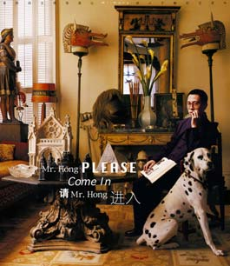
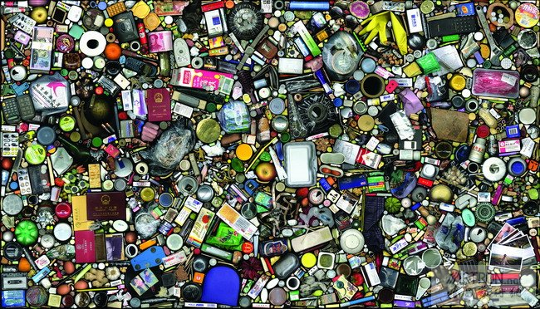

洪浩用“我的物品”象征了人的物质化。
My things is used to symbolize the materialization of the people.

11、杨福东——《竹林七贤》
The Seven Sages of the Bamboo Grove series, by Yang Fudong
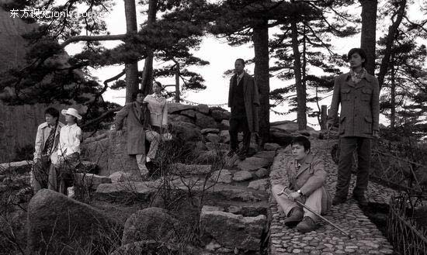

作品利用中国魏晋时期的七个文人故事传说，用影像的方式拍摄了七个新时代的中国年轻人的生活之梦，从乡村来到城市，又返回乡村，反映了他们的生活状态。
These works are conceived based on the stories of the seven scholars in the Wei and Jin Dynasties of ancient China. They are about seven young people who migrate from the villages to the city and then go back to the villages again. The photos reflect the living status of the young people in the new age.

12、李暐 ——《李暐撞入红场秀》与《镜子·香港》
Li Wei falls to the Red Square and Mirror Hongkong, by Li wei

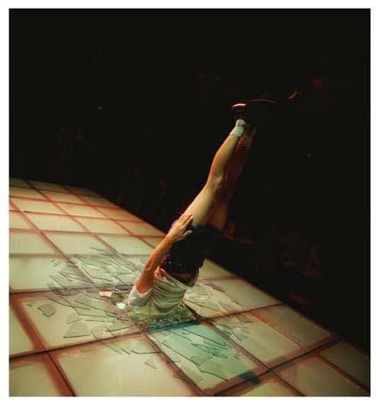
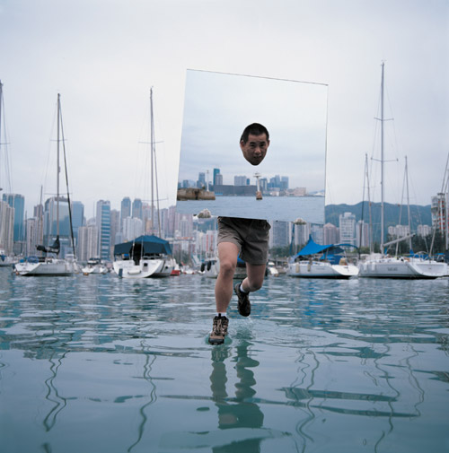

作品突显了被改变的个体经验，意味着艺术想象对生活的介入。
The works highlight the changed personal experience, implying the intervention of arts to life.

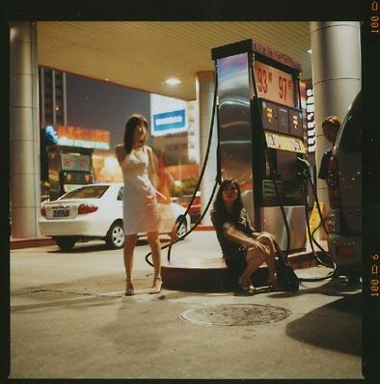
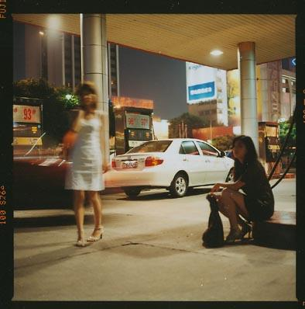
13、杨勇——《青春日记》
The Diary of the Youth, by Yang Yong

作品想象了现代中国的一种伤感。
The works show a kind of imagined sentiment in modern China.
第三部分 传统反思
Section III Reflection on Tradition

中国艺术家在拥抱摄影的同时，再次将目光投向自己的文化、历史和传统。而当代影像因其多元丰富的表现手段和巨大的视觉潜力也为这样的命题提供了前所未有的表现可能。艺术家们也借此追寻着他们心中的梦想和情结，将历史和传统无比“真实”地拉入现实中来，使观者在视觉体验的新奇中获得感悟。

Chinese artists who devote themselves to photography pay much attention to the culture, history and tradition of China. Meanwhile, Chinese contemporary photography, integrated with diversified expression and great visual potential, provides a good environment for artists to reflect on traditions and to pursue their ideals. Chinese artists therefore get the chance to integrate history and tradition into reality and enable the people who look at the photos to get some inspiration from the visual experience.

14、刘铮——《新戏剧》
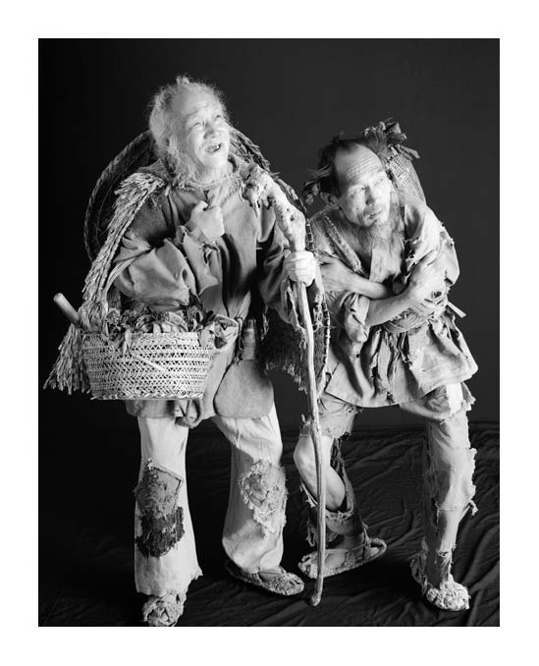
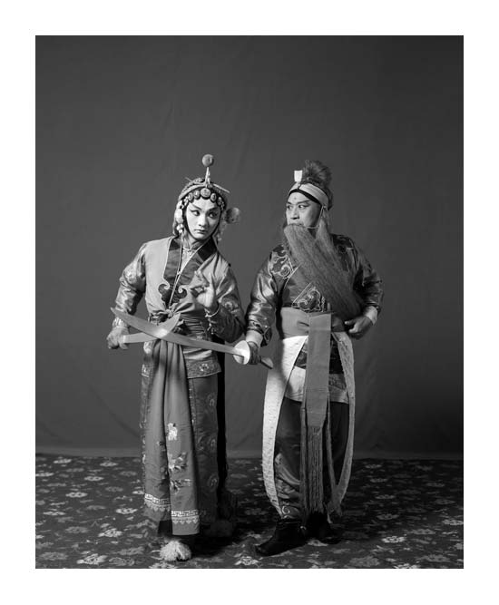
The New Opera, by Liu Zheng

《新戏剧》用影像塑造人物的方式，给观众上演了一出无声剧，提出了戏剧语言如何视觉化的问题。
The New Opera series put on a silent show by creating various images, helping to make the opera language visible.
15、姚璐——《新中国山水》系列
The Landscape of New China, by Yao Lu

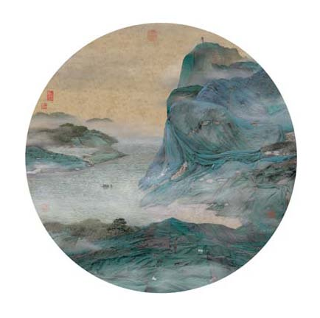

《清崖横云图》 The Cliff Shrouded by Clouds, by Yao Lu

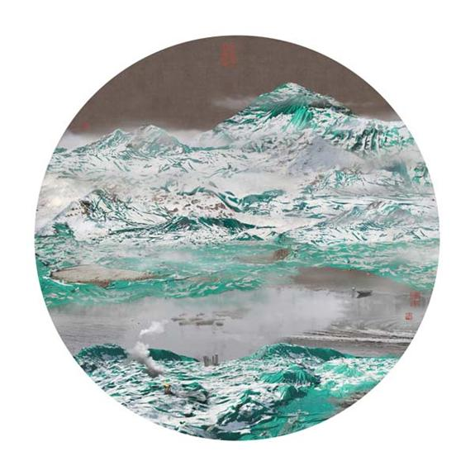

《江村雪霁图》 The Riverside Village after Snow, by Yao Lu

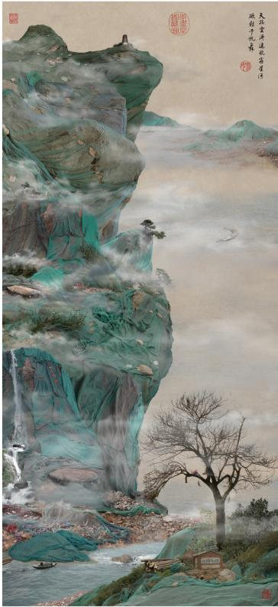
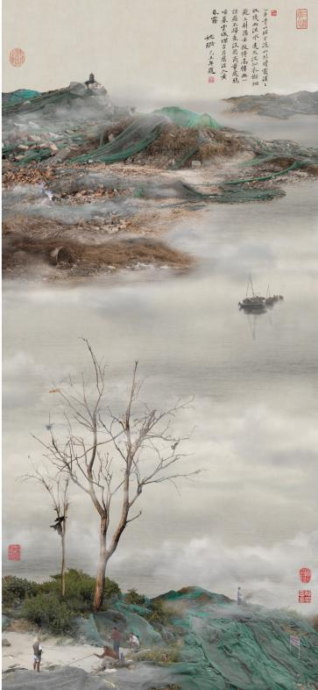

《绝岭翠微图》 《浅渚垂钓图》
The Verdant Mountain Range, by Yao Lu Fishing in an Islet, by Yao Lu
作品借用传统青绿山水的图式，但表达的是现代中国的建设工地，巧妙地将现代化置于传统变革之中，也就是我们既走在现代的道路上，也须臾不离传统。
In these works, the construction sites of modern China are expressed in a traditional way. Both modern and traditional elements are contained, meaning that China will not give up its traditions though it is stepping forward into modern development.
16、马良——《草船借箭》
To borrow Arrows with Thatched Boats, by Ma Liang
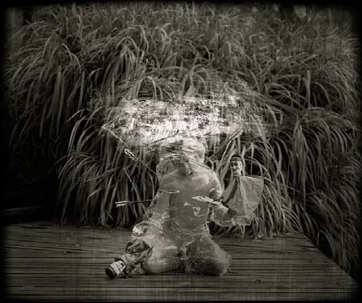
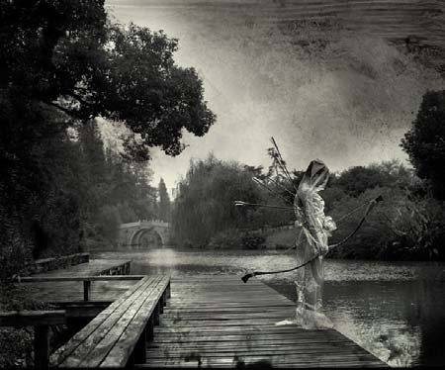

作品利用中国传统的文学故事，来营造一个神秘的世界，但非连续性的画面又留下了无尽的遐思。
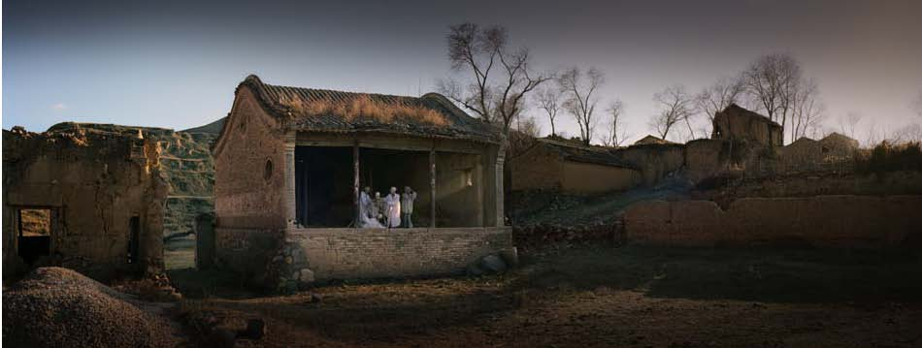
The works are based on a traditional literary story of China. A mysterious world is created. Meanwhile the disconnected pictures leave more space for people to imagine.

17、庐晓川——《最后的晚餐》、《微光》

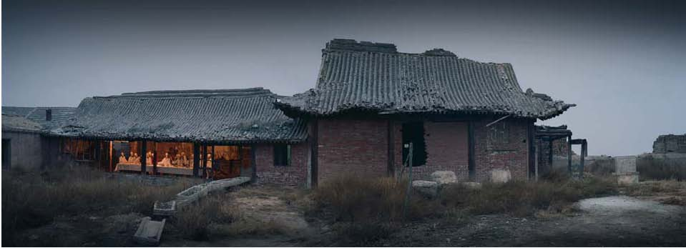
《最后的晚餐》The Last Dinner, by Lu Xiaochuan

《微光》In the Dim Light, by Lu Xiaochuan
该系列的作品像乡村遗照一样，反思着逝去的传统和文化痕迹。
The photos are more like records of a disappeared village. They make people think about the tradition and culture that have disappeared.

18、邱志杰——《24节气》
The 24 Solar Terms, by Qiu Zhijie

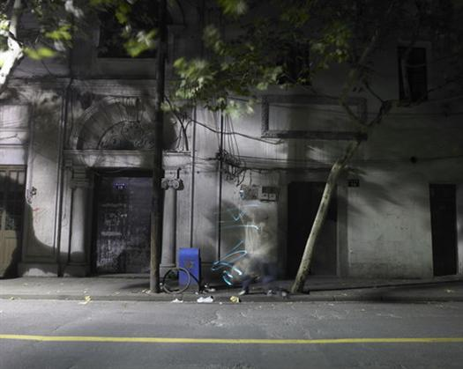
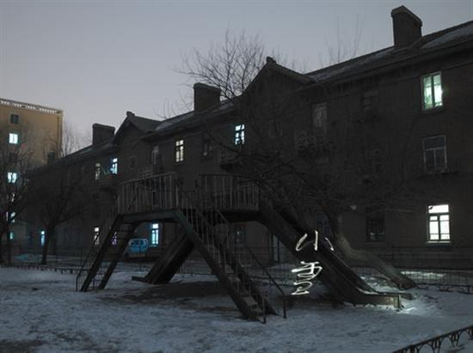
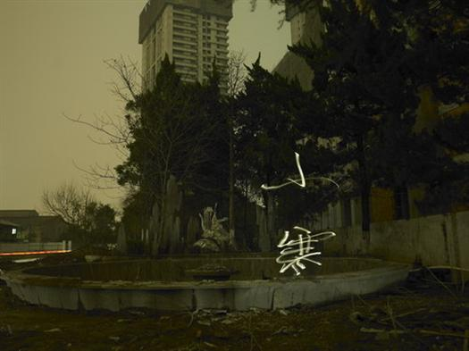
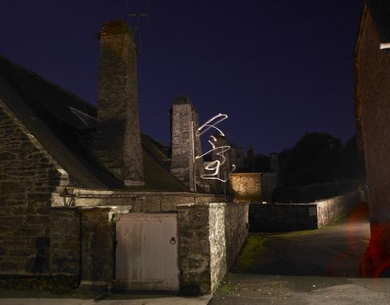

《24节气》把时间变化的冷暖予以视觉化，让观众体验时间的存在。
These photos make the people feel the existence of time by visualizing the changes of the climate.

19、许昌昌——《别动我的向日葵》、《再见江南》
Don't Touch My Sunflower and Back to Southeast China, by Xu Changchang

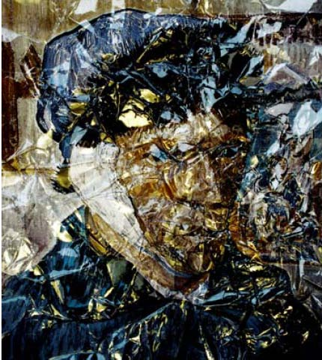
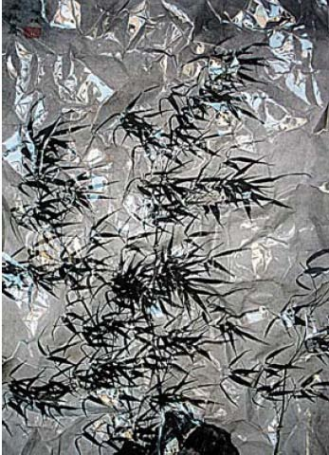

《别动我的向日葵》 《再见江南》
Don't Touch My Sunflower, by Xu Changchang Back to Southeast China, by Xu Changchang

作品以图像的再利用来颠覆图像的意义，重新构造视觉世界。
These works use recycled images to build up a new visual world and give these images some new meaning.

第四部分 数字影像
Section IV Digital Photography

摄影是伴随着科技的发展而迅速成长的视觉表现媒介，科学技术的每一次革命都会为摄影的表现提供新的拓展空间，同时也会带来关于这个媒介自身的一系列新的问题。诸如新技术与摄影传统的契合关系、新技术下摄影的边界以及形态、影响的评判与审美标准的变化等等。对此，艺术家们孜孜以求的探索从未停息。随着数字技术的迅速普及，上述问题再一次成为摄影本体探索的新命题。这方面的艺术实践也造就了众多崭新的视觉样式和相应的创作主题，也成为当代影响中极具代表性的组成部分。

Photography is a kind of visual expression media developed with the rapid development of technologies. Each technological reform has brought new opportunities for the development of photography and new problems as well, for example, the relationship between new technologies and traditional photography, the limit to the photography under the development of the new technologies, the change of the evaluation on the form and influence of the photography, and the change of the aesthetical standards. Facing these problems, Chinese artists have never stopped their exploration. With the rapid development of digital technology, solving the above-mentioned problems has become a new task of photography artists. Thanks to unremitting practices, many more visual forms and themes have been created and have become important parts of contemporary photography.

20、冯梦波——《乱码山水》
The Painting of Scrambled Landscape, by Feng Mengbo
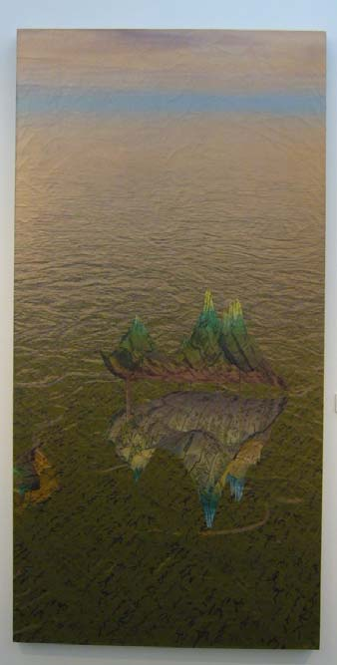
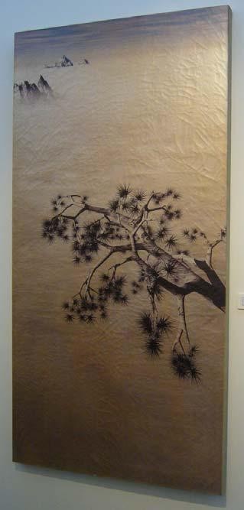

作品用数码手段来再现出中国的古典绘画的浪漫意境，有空阔和静谧的感觉。
These photos show the romantic images of classical Chinese drawings by using digital means. They make people feel the spaciousness and the quietness.

21、马刚——《自若》
Self Poised, by Ma Gang
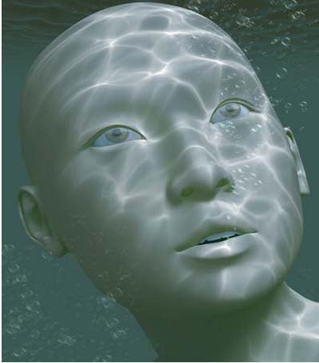
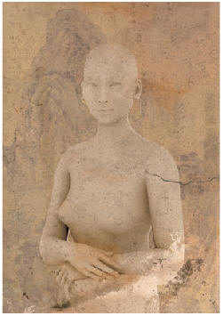

《水生》 《自若》
Born in Water, by Ma Gang Self Poised, by Ma Gang
作品探索了数码化之后的艺术史和图像创造。
These photos represents an exploration of the digitalized arts history and imaging creation.

22、王川——《燕京八景系列》之金台夕照和蓟门烟树
The Golden Terrace under Afterglow and Trees at Jimen Gate in the Mist: Two of the Eight Famous Sights in Ancient Beijing, by Wang Chuan
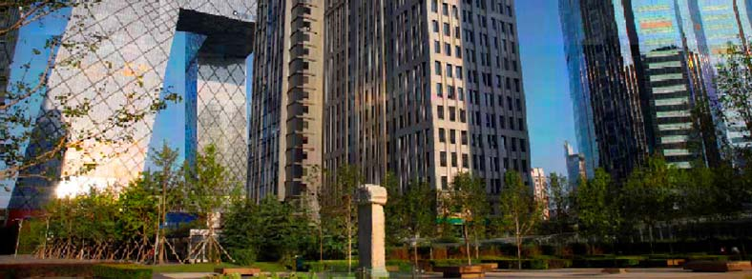
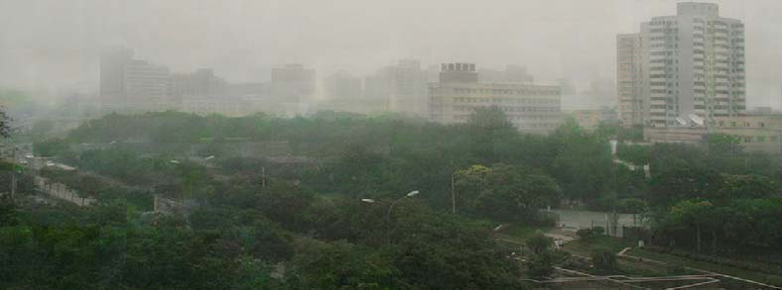

《燕京八景系列》将数码的构成基础——像素作为探索数码艺术的基点，来反映现代化北京的古今变化。
These photos reflect the change of Beijing over time. Pixel, the fundamental element of the digit, has been applied as the base point for the exploration of the digital arts.

23、白宜洛——《宿命》
The Fate, by Bai Yiluo
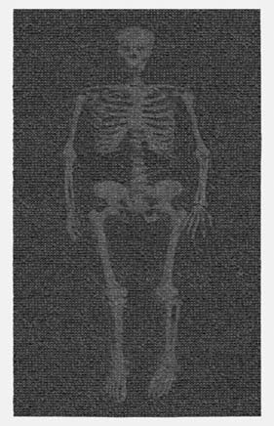
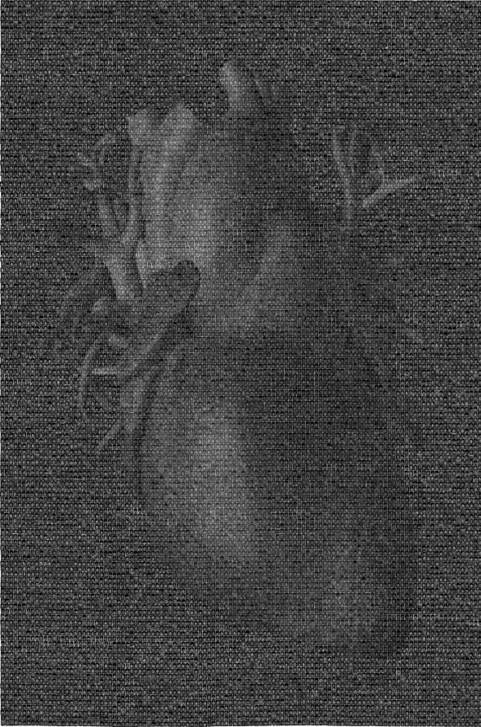

白宜洛的影像作品都是以小照片构成，这些个展人像组成画面就隐喻了我们的生命和价值。
The works of Bai Yiluo are composed of small pictures to symbolize our lives and the value of the lives.

24、计舟——《工地系列》

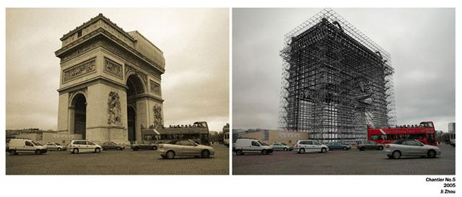

《工地5号》The Scaffold #5by Ji Zhou
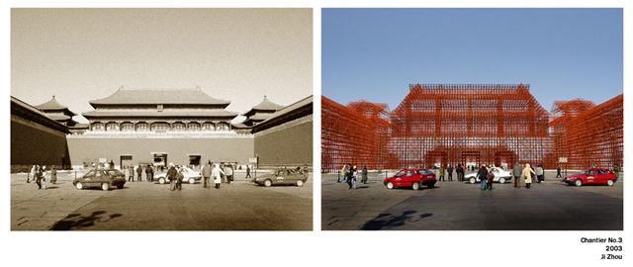

《工地3号》The Scaffold #3, by Ji Zhou
计舟的作品寻求历史与现在、现实与想象之间的过渡。
Through these works, Ji Zhou tends to find the transition from the past to today and the transition from reality to imagination.

25、陈曼——《单米奇》、《双米奇》

Single Mickey Mouse and Double Mickey Mouse, by Chen Man
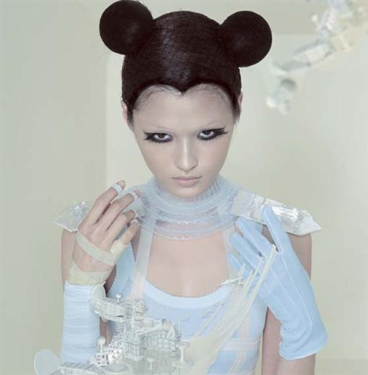

《单米奇》Single Mickey Mouse, by Chen Man
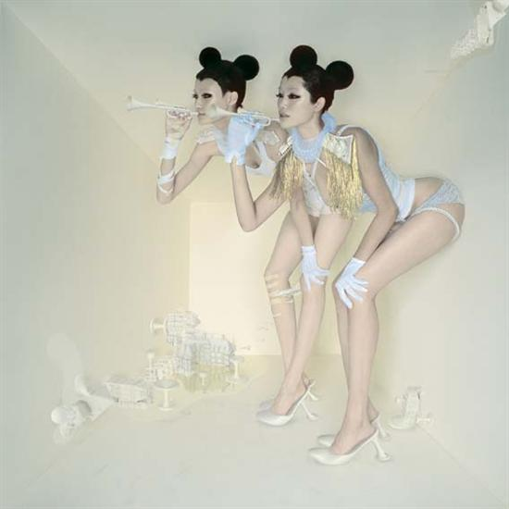

《双米奇》Double Mickey Mouse, by Chen Man

陈曼的作品以美轮美奂见长，将人物塑造为神秘气质的形象，追求独特的影像表现能力。
Chen Man is good at taking beautiful pictures. These photos, with special imaging expression characteristics, show a kind of mysterious temperament of the figures.

