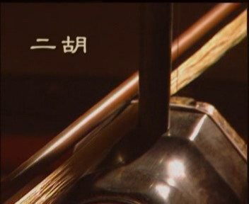 | 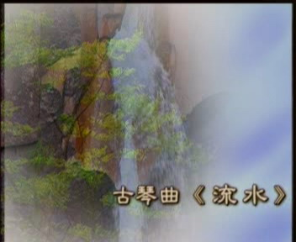 | 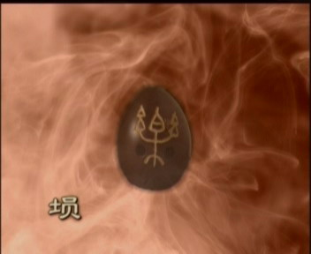
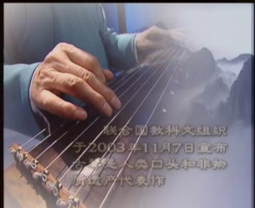 | 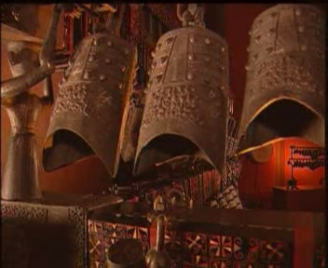 | 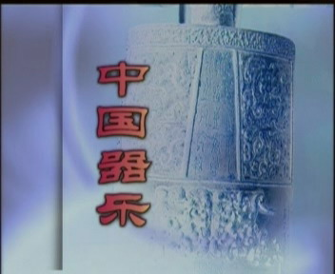

TV Documentary
Chinese Instrumental Music

Chinese instrumental music has an ancient history and comes in a myriad of types and styles, each with its own special characteristics. The compositions “Moon Reflects on the Er-quan Spring” and “Ambush on All Sides” flow out from echoes off the slightly quivering strings of the qin, or zither. Rich percussion and tones from wind instruments beat out the meeting of ancient music and modern appreciators. Chinese classical music can be tragic, cheerful, melodious or strongly rhythmic… In different areas and among different peoples, moving, emotive music continues to be passed from one generation to the next, reflecting the vitality of China’s ancient civilization and its extraordinary capacity for absorbing anything and everything.

Producers: Ding Wei, Li Xin
Executive Producers: Zhuang Lixiao, Shu Jianping
Art Supervisor: You Fei
Director: Hong Mei
Director of Photography: Guang Dongpei
Coordinator: He Ta
Produced by Beijing Wangtu Film and TV Production Consulting Co., Ltd
Translated by Center of International Cultural Exchange
Presented by the Bureau for External Cultural Relations,
Ministry of Culture, P.R. China

