Celebrating the 10th Anniversary of Macao's Return to China

THE CHARM OF MACAO

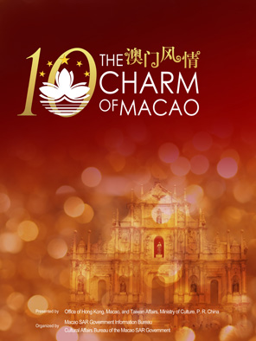
1. The Charm of Macao

Presented by:
Office of Hong Kong, Macao, and Taiwan Affairs, Ministry of Culture, P. R. China

Organized by:
Macao SAR Government Information Bureau
Cultural Affairs Bureau of the Macao SAR Government

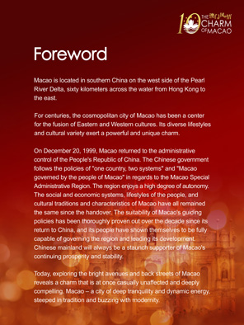
2. Foreword

Macao is located in southern China on the west side of the Pearl River Delta, sixty kilometers across the water from Hong Kong to the east.

For centuries, the cosmopolitan city of Macao has been a center for the fusion of Eastern and Western cultures. Its diverse lifestyles and cultural variety exert a powerful and unique charm.

On December 20, 1999, Macao returned to the administrative control of the People's Republic of China. The Chinese government follows the policies of "one country, two systems" and "Macao governed by the people of Macao" in regards to the Macao Special Administrative Region. The region enjoys a high degree of autonomy. The social and economic systems, lifestyles of the people, and cultural traditions and characteristics of Macao have all remained the same since the handover. The suitability of Macao's guiding policies has been thoroughly proven out over the decade since its return to China, and its people have shown themselves to be fully capable of governing the region and leading its development. Chinese mainland will always be a staunch supporter of Macao's continuing prosperity and stability.

Today, exploring the bright avenues and back streets of Macao reveals a charm that is at once casually unaffected and deeply compelling. Macao – a city of deep tranquility and dynamic energy, steeped in tradition and buzzing with modernity.
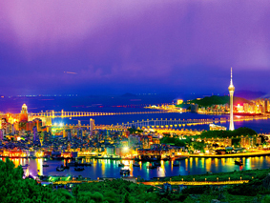
- Panorama of Macao

Macao is linked to the city of Zhuhai on the Chinese mainland by an overland road. Macao has a population totaling 530,000 living in an area of only 30 square kilometers. The official languages are Chinese and Portuguese. Lotus flowers are greatly beloved by the people of Macao, and the Macao flag and the regional emblem both depict an open lotus. The three petals of the lotus symbolize the Macao peninsula and its two outlying islands, Taipa and Coalane.
Photo by Zhu Zehui
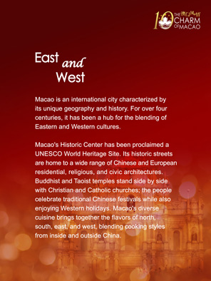
4. East and West

Macao is an international city characterized by its unique geography and history. For over four centuries, it has been a hub for the blending of Eastern and Western cultures.

Macao's Historic Center has been proclaimed a UNESCO World Heritage Site. Its historic streets are home to a wide range of Chinese and European residential, religious, and civic architectures. Buddhist and Taoist temples stand side by side with Christian and Catholic churches; the people celebrate traditional Chinese festivals while also enjoying Western holidays. Macao's diverse cuisine brings together the flavors of north, south, east, and west, blending cooking styles from inside and outside China.
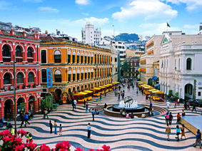
- Witness to history

Macao's Historic Center contains China's oldest existing assemblage of Eastern and Western architecture. These buildings bear witness to over 400 years of Eastern and Western cultural exchange, diversity, and coexistence. Most of the structures are perfectly preserved, and many maintain their original function and appearance. The Historic Center is listed as a UNESCO's World Heritage Cultural Site. Pictured is Senado Square, located in Macao's Historic Center.
Photo supplied by Cultural Affairs Bureau of the Macao SAR Government

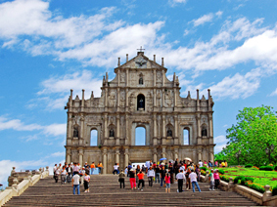
- The symbol of Macao

The Ruins of St. Paul's consist of the remaining facade of the Cathedral of St. Paul. The centuries old ruins are a classic example of European Renaissance baroque architecture. The Ruins of St. Paul's are the symbol of Macao, as well as a popular gathering place. Many festivals, holidays, and folk activities are celebrated here.
Photo supplied by Cultural Affairs Bureau of the Macao SAR Government

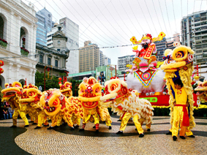
- Lion Dance adds to the fun

The Lion Dance is an old Chinese tradition, performed at festivals and gatherings to heighten the celebratory atmosphere. This custom has been maintained in Macao, where a wide range of important ceremonies include performances of the Lion Dance. Dressed in lion costumes, the energetic dancers imitate the lion's movements to the accompaniment of drums and gongs, in celebration of the grand event.
Photo supplied by Macao SAR Government Information Bureau

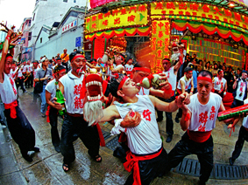
8. Drunken Dragon Dance

The Drunken Dragon Dance is an ancient folk tradition that has its origins in Guangdong Province. Unlike the standard dragon dance, the dancers carry only the head and tail of the dragon, and not the body. The dancers drink throughout the performance, occasionally spraying mouthfuls of wine towards the heavens. As they become more and more intoxicated, their gestures become increasingly broad and hilarious. The Feast of the Drunken Dragon is held every year on the eighth day of the fourth lunar month, in order to commemorate the ancestors and pray for peace.
Photo supplied by Cultural Affairs Bureau of the Macao SAR Government
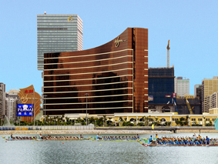
9. Dragon boat race

China's traditional Dragon Boat Festival has a history reaching back over 2000 years. The festival is most commonly celebrated by eating zongzi (sticky rice dumplings wrapped in bamboo or reed leaves) and holding dragon boat races. The annual Macao International Invitational Dragon Boat Race draws not only athletes from Chinese mainland and Macao, but also teams from other countries to participate in the great competition.
Photo supplied by Macao SAR Government Information Bureau

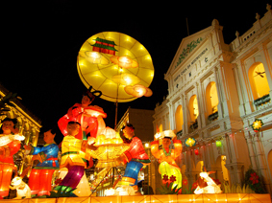
10. Mid-autumn Festival

China's traditional Mid-autumn Festival is a favorite holiday of the people of Macao. On the night of the festival, colored lanterns of every shape and size festoon the parks, streets, squares, and buildings, illuminating the entire city with a celebratory glow.
Photo supplied by Cultural Affairs Bureau of the Macao SAR Government

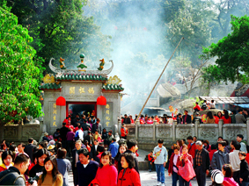
11. Protector of seafarers

Almost every temple and church in Macao holds images of divine beings. Gods and goddesses of East and West, Chinese Buddhas and Bodhisattvas, deities of all countries coexist peacefully on this small island. Incense rises from the beautiful A'Ma Temple, over 500 years old. The temple is dedicated to the goddess Matsu, worshipped by the people of the southern Chinese coast as the protector of seafarers.
Photo supplied by Cultural Affairs Bureau of the Macao SAR Government

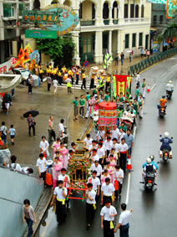
12. Prayer procession

Na Tcha is a protective deity of Buddhist and Taoist tradition, known by every family in China. Every year on the eighteenth day of the fifth lunar month, Na Tcha's followers hold a grand ceremony at Macao's Na Tcha Temple, and then carry an image of the god on a prayer procession around the island. The entire event is carried out according to traditions that are centuries old.
Photo supplied by Cultural Affairs Bureau of the Macao SAR Government
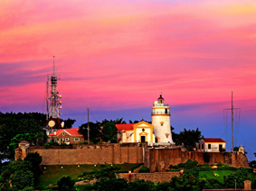
13. Guia lighthouse

Macao's lighthouse is located on Guia Hill, the highest point in Macao, looking east over the South China Sea. Over 140 years old, it is the first lighthouse in far-east Asia. It marks Macao's official geographical coordinate. Next to the lighthouse is a Catholic chapel over 400 years old dedicated to Our Lady of Guia, the Portuguese protector of seafarers.
Photo by Chen Xianyao

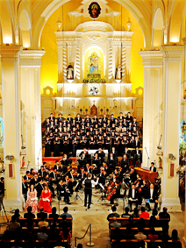
- Religious culture

On the streets of Macao, classical churches and cathedrals vie for attention with the unique elegance of traditional Chinese temples. Enhancing each other's beauty, these emblems of religious culture have coexisted harmoniously for hundreds of years, bearing witness to the blending of East and West that characterizes Macao. Pictured is an Easter concert being held at Macao's St. Dominic's Church, which is over 400 years old.
Photo supplied by Cultural Affairs Bureau of the Macao SAR Government

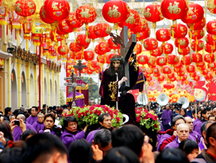
15. Peaceful coexistence

Among the people thronging the streets of Macao are Catholics, Protestants, Buddhists, Taoists, Confucianists, and nonbelievers, all living peacefully together. For centuries there has been no religious conflict in Macao. Pictured are celebrants carrying an image of Jesus on a procession through town.
Photo supplied by Cultural Affairs Bureau of the Macao SAR Government

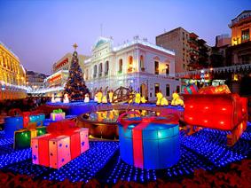
16. Western New Year

People in Macao celebrate two different New Year's holidays every year – the Christmas holiday of the West, and China's Spring Festival. Pictured is Christmas Eve on a street in Macao.
Photo by Chen Xianyao

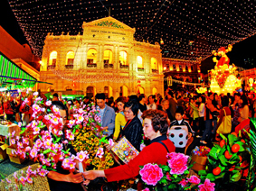
17. Chinese New Year

Of all traditional Chinese holidays, none is more important than the Lunar New Year's Spring Festival. This is also true in Macao. On Lunar New Year's Eve, family members gather together for the traditional reunion dinner. Later they go out to stroll through Macao's flower markets, where they purchase auspicious plants and flowers with which to decorate their homes and welcome in the new year.
Photo supplied by Macao SAR Government Information Bureau

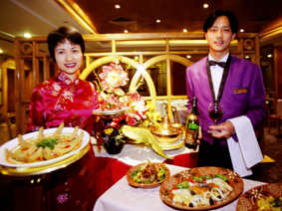
18. A fusion of cuisines

Macao is a meeting place of Chinese and foreign cultures. Cuisines from around the world and every corner of China have been blended into a diverse banquet of flavors, perfected and adapted for Chinese tastes. Macao-style Portuguese cuisine is a fusion of the best elements of Portuguese, African, Indian, Malaysian, and Chinese cooking. Pictured is a Portuguese restaurant in Macao.
Photo supplied by SuperStock
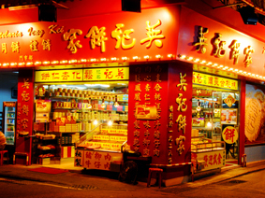
19. Snacks

Macao has a great tradition of snack foods, referred to as shouxin. Among over a hundred local favorites are almond cookies, egg tarts, peanut candy, and beef jerky. Besides being enjoyed between meals, snacks are often given as gifts. Pictured is a shouxin snack shop.
Photo supplied by Cultural Affairs Bureau of the Macao SAR Government
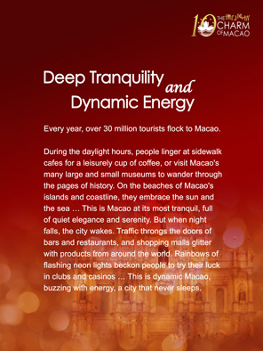
20. Deep Tranquility and Dynamic Energy

Every year, over 30 million tourists flock to Macao.

During the daylight hours, people linger at sidewalk cafes for a leisurely cup of coffee, or visit Macao's many large and small museums to wander through the pages of history. On the beaches of Macao's islands and coastline, they embrace the sun and the sea … This is Macao at its most tranquil, full of quiet elegance and serenity. But when night falls, the city wakes. Traffic throngs the doors of bars and restaurants, and shopping malls glitter with products from around the world. Rainbows of flashing neon lights beckon people to try their luck in clubs and casinos … This is dynamic Macao, buzzing with energy, a city that never sleeps.
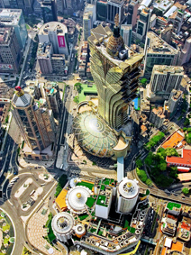
21. Scenic and cultural attractions

Every year tens of millions of visitors, representing all colors and languages of the human family, are drawn to explore Macao's beautiful natural scenery and enjoy its unique cultural attractions.
Photo supplied by Macao SAR Government Information Bureau

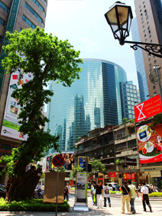
22. Oases of calm

Whether taking a break at an outdoor café or exploring Macao's grand avenues and back streets, one may always find pockets of peace and quiet in the midst of the busy city.
Photo supplied by Macao SAR Government Information Bureau
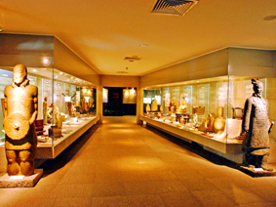
23. A concentration of history and culture

Macao has a multitude of museums of all types and sizes, offering concentrated glimpses of local history and culture. The people of Macao love and support their museums, conscientiously maintaining and displaying their treasures to be shared with the world. Pictured is the Macao Museum.
Photo supplied by Cultural Affairs Bureau of the Macao SAR Government

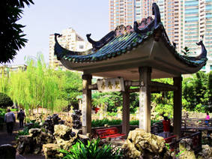
24. Drawing close to nature

Macao's several dozen parks offer the residents of a clamorous city the opportunity to draw close to the peace and quiet of nature. Pictured is Lulianruo Park. The park's pavilions and terraces, ponds, bridges, and waterfalls are as beautifully designed as a poem or painting. Lulianruo Park is the only traditional Chinese park in the Macao and Hong Kong area.
Photo by Anonymous

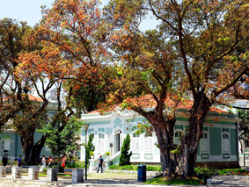
25. Portuguese houses on Taipa Island

The Portuguese-style houses on Macao's Taipa Island are among Macao's most famous cultural attractions. Taipa Island is sometimes referred to in Chinese as "Dragon Ring," so the houses are also called "Dragon Ring Portuguese Houses." Full of shady green trees, flowers, and bushes, this neighborhood is peaceful and lazy, its elegance tinged with the romance of tradition. It is a far cry from the noise and energy of Macao's city streets.
Photo supplied by Macao SAR Government Information Bureau

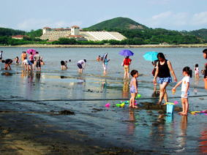
26. Black sand beach

Macao's extraordinary Hac Sa Beach stretches along the coast in an expanse of sparkling black sand. As the white capped ocean breakers crash against the shore, the contrast of white spray and black sand creates a remarkable and arresting sight. Pictured is Hac Sa Beach, Macao's famous leisure attraction.
Photo by Yang Mingjing

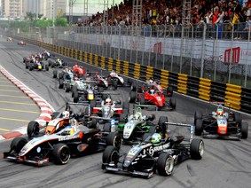
27. Greased lightening

Every year, Macao's Grand Prix motor-racing event turns the usual leisurely pace of life in Macao upside down. This is the only international street circuit racing event to hold races for formula cars, RVs, race cars, and motorcycles on the same track. For over five decades, the Macao Grand Prix has attracted the best of the world's racers, as well as multitudes of race fans.
Photo supplied by Macao SAR Government Information Bureau

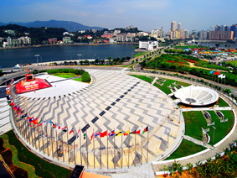
28. A new era

Recent years have seen the construction of numerous new tourist attractions and facilities in Macao. Combining East and West, tradition and modernity, these great projects help propel the international capital of Macao into a new era. Pictured is the Macao Tower Entertainment and Convention Center.
Photo supplied by Macao SAR Government Information Bureau

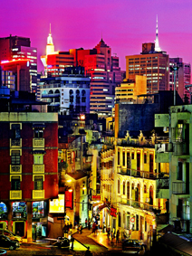
29. A city that never sleeps

When night falls, Macao is transformed. Mystery and romance may be found around every corner, and the glamour, ease, and excitement of a big city beckon.
Photo supplied by Macao SAR Government Information Bureau

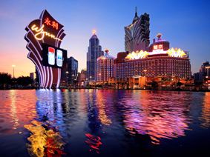
30. A brilliant palette

Gambling in Macao has a long history, now entering its third century. Gaming is one of Macao's oldest industries, as well as one of its most vital. Deep in the night, when the lights are at their brightest, Macao's all-night casinos are most exciting place to be.
Photo by Chen Xianyao

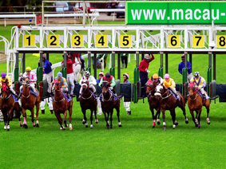
31. Betting on the races

When evening comes, a visit to Macao's horse and greyhound tracks offers the opportunity to sit back and watch the races, or enjoy the risk and excitement of placing a bet on a favorite.
Photo supplied by Macao SAR Government Information Bureau

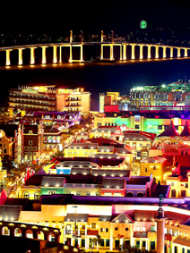
32. Streets of dreams

Fisherman's Wharf is Macao's first theme park. Exploring the nooks and crannies of the park is like taking a voyage through space and time. Traveling from the streets of ancient Rome to the palaces of China's Tang Dynasty, from the wonders of ancient Greek myth to the romance of One Thousand and One Nights, this is a place that visitors never want to leave.
Photo supplied by Macao SAR Government Information Bureau

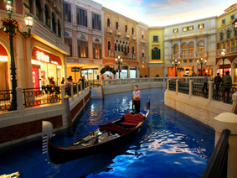
33. Pleasures abound

Macao is filled with bars, clubs, and dance halls of every type and persuasion. When night comes, groups of friends hit the town together, drinking and talking, dancing and singing, carousing until they finally make their way home. Pictured is an artificial canal at the Venetian Macao Resort.
Photo by Li Jianquan

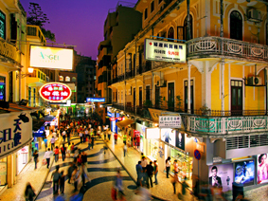
34. Shopper's paradise

Macao is a veritable shopper's paradise, offering a huge assortment of products at bargain prices. Many stores stay open all night, making the shopping experience even more enjoyable.
Photo by Chen Xianyao

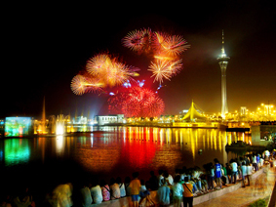
35. Fireworks light up the sky

Since its inception in 1989, Macao's annual International Fireworks Display Contest has become one of the city's most celebrated tourist attractions. Every year, thousands upon thousands of visitors from around the world flock to Macao to attend the incredible show. Riotous bursts of light explode across the sky, echoed by rainbows of colored lanterns lining the streets below. This is the epitome of the romance that is Macao.
Photo supplied by Macao SAR Government Information Bureau

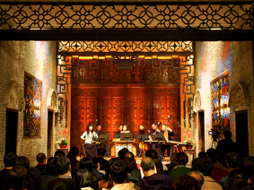
36. Music fills the air

Music provides a constant accompaniment to life in Macao, with performers of every type of music taking the stage at a wide range of venues. Pictured is the Macao Chinese Orchestra performing traditional Chinese music at a classical Chinese mansion.
Photo supplied by Cultural Affairs Bureau of the Macao SAR Government

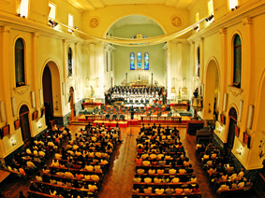
37. Mutual harmony

Concerts held in ancient cathedrals are among Macao's many unique cultural attractions. As magnificent music and classical Western architecture blend together in mutual harmony, each enhances the other's beauty.
Photo supplied by Cultural Affairs Bureau of the Macao SAR Government

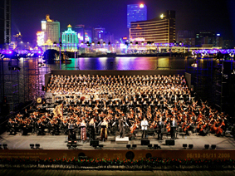
38. A smorgasbord of culture

Macao's unique blend of cultures has given rise to a distinctive cultural brand. Every year, Macao's International Art Festival and International Music Festival attract numerous domestic and foreign artists, performers, and visitors. This smorgasbord of culture encompasses the great sweep of East and West, spanning numerous ethnicities and eras.
Photo supplied by Cultural Affairs Bureau of the Macao SAR Government

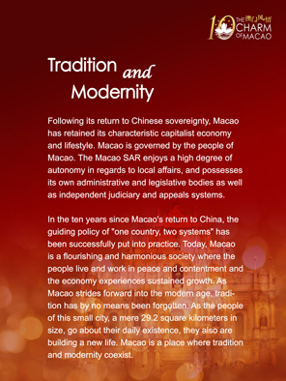
39. Tradition and Modernity

Following its return to Chinese sovereignty, Macao has retained its characteristic capitalist economy and lifestyle. Macao is governed by the people of Macao. The Macao SAR enjoys a high degree of autonomy in regards to local affairs, and possesses its own administrative and legislative bodies as well as independent judiciary and appeals systems.

In the ten years since Macao's return to China, the guiding policy of "one country, two systems" has been successfully put into practice. Today, Macao is a flourishing and harmonious society where the people live and work in peace and contentment and the economy experiences sustained growth. As Macao strides forward into the modern age, tradition has by no means been forgotten. As the people of this small city, a mere 29.2 square kilometers in size, go about their daily existence, they also are building a new life. Macao is a place where tradition and modernity coexist.
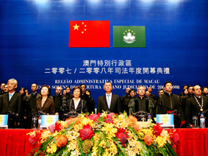
40. An independent judiciary

According to the policy of “one country, two systems”, Macao's legal system remains essentially unchanged and its judicial system has been in large part preserved. Over the last ten years, Macao's original legal system, the spirit of its laws, its human rights, and its independent judiciary have been fully protected and implemented. Pictured is the opening ceremony of the Macao SAR Annual Judiciary Conference.
Photo supplied by Macao SAR Government Information Bureau

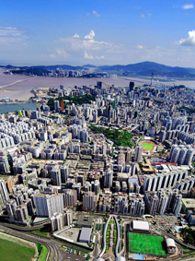
41. A free market economy

Macao possesses a flourishing and open free market economy. The main sectors of the economy are export manufacturing, tourism and gambling, finance, and real estate and construction. As of 2007, Macao's per capita GDP was the highest in Asia. In 2009, Macao's Index of Economic Freedom ranked the 21st in the world.
Photo supplied by Macao SAR Government Information Bureau

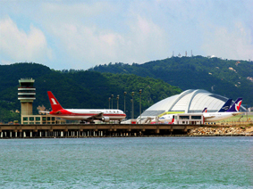
42. Developing transportation links

Recent years have seen a great surge in the number of people traveling to Macao. Macao has accordingly expanded its overland transportation links to the Mainland, as well as its external maritime and air routes. Not only has shipping traffic between Macao and Hong Kong increased, Macao's international airport has undergone extensive expansion.
Photo supplied by Macao SAR Government Information Bureau

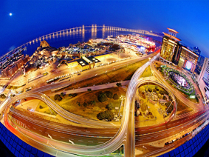
43. An efficient highway network

Three huge bridges and a reclaimed land causeway link the peninsula of Macao with Taiba and Coloane, its two offlying islands. Macao's network of highways totals 400 kilometers in length. Although the density of motor vehicles approaches 435 per kilometer of roadway, traffic flows freely. This is thanks both to Macao's highly efficient system of traffic control and regulation, and to the high degree of safety awareness and the respectfulness of Macao's motorists.
Photo by Chen Xianyao

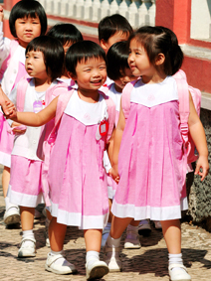
44. Building an educational foundation

Macao provides its citizens with 15 years of free primary and secondary education. The educational system includes both public and private schools, with a choice of Chinese, English, or Portuguese as the language of instruction. Many of Macao's institutes of higher learning are distinguished by their cultural diversity, atmosphere of open academic exchange, and advanced pedagogic methods, attracting many students from the Mainland to take part in their competitive entrance exams.
Photo supplied by Macao SAR Government Information Bureau

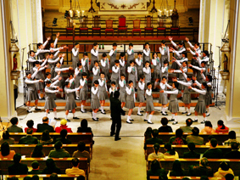
45. Art education

Macao's "Secondary School Art Education Plan" calls for all secondary school students to be exposed to a variety of performance art, and to personally participate in one public performance per year. Through these artistic performances, the students come to respect the significance of art and its place in life, and also learn how to conduct themselves in public. Pictured are students learning how to perform.
Photo supplied by Cultural Affairs Bureau of the Macao SAR Government

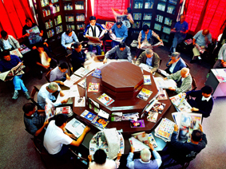
46. An abundance of information

Not only does Macao protect freedom of the press and freedom of speech, it also is a world hub of news and information. In addition to almost thirty local newspapers and periodicals in Chinese, Portuguese, and English, dozens of publications from Hong Kong are delivered to Macao every day. Macao's per capita newspaper and magazine consumption is among the highest in the world. Pictured is the Chinese Octagonal Reading Room, where residents may read for free.
Photo by Chen Xianyao

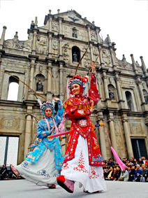
47. Charming music, elegant dance

Guangdong opera, which originated in Chinese mainland, is greatly beloved by all circles of society in Macao. Macao's hundreds of amateur Guangdong opera troupes are always eager to take the stage, whether at a government sponsored art festival or a traditional folk holiday. Pictured is a performance of Guangdong opera at the Macao Art Festival.
Photo supplied by Macao SAR Government Information Bureau

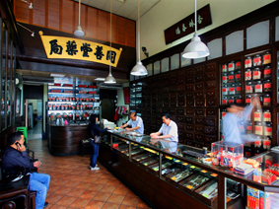
48. An ancient heritage

Traditional Chinese medicine is an ancient heritage of the people of Macao. The traditional daily tonics taken by the people, the apothecaries that line the streets, and the multitude of private clinics large and small, all reflect the deep influence of traditional Chinese medicine in Macao. Pictured is one of Macao's oldest and most famous traditional Chinese apothecaries.
Photo by Chen Xianyao

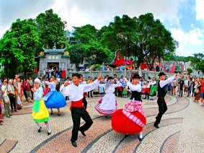
49. The Macanese population

The term "Macanese" refers of people of Portuguese ancestry who have lived in Macao for many generations. Maintaining their unique Portuguese cultural heritage, this group enriches Macao's local culture and embodies Macao's social diversity. Today, Macao's many different societal groups live together in harmony, creating a happy, stable, and prosperous society. Pictured are Macanese dancers performing a traditional Portuguese folk dance.
Photo supplied by Macao SAR Government Information Bureau

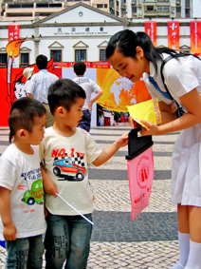
50. Acts of kindness

The people of Macao have a long history of enthusiastic participation in charitable enterprises. As Macao's economy has flourished, its people have not forgotten their social obligation to actively assist those in need. At the same time, their great contributions to disaster relief in Chinese mainland embody the bond that exists between the people of Macao and the Mainland. The blood ties of compatriots will always be deeper than the water that separates them. Pictured are volunteers collecting donations for disaster relief on the Mainland.
Photo supplied by Macao SAR Government Information Bureau

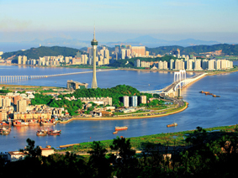
51. Close connections

Macao has always been Chinese mainland's important trading partner, as well as its window and bridge to the outside world. For many years, Macao and the Mainland have had unbreakable trade relations. The signing of the Mainland and Macao Closer Economic Partnership Arrangement (CEPA) in 2003 has further accelerated the joint development between Macao and the Mainland. Pictured is Macao’s West Bay Bridge.
Photo by Chen Xianyao

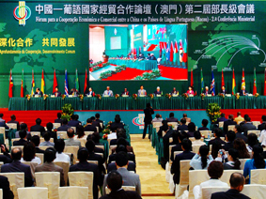
52. Building a trade platform

With the globalization of the world economy, China's trade relations with Portuguese-speaking countries have developed rapidly. Macao's advantages in the areas of language, culture, commerce, communications, and services, have enabled it to become the primary trade platform for these relations. At the same time, Macao has strengthened regional cooperation and brought about economic diversification. Pictured is the Ministerial Conference of the Forum on Economic and Trade Cooperation between China and Portuguese-speaking Countries.
Photo by Shi Li

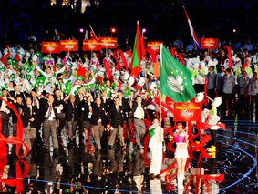
53. Athletic events

Macao is committed to developing physical education opportunities and athletic competition for its residents. Year round athletic competitions not only improve the overall physical fitness of the people, but also raise Macao's international standing. Sports tourism has become Macao's newest industry. Pictured is the Macao team taking the floor at the Asian Indoor Games.
Photo supplied by Macao SAR Government Information Bureau
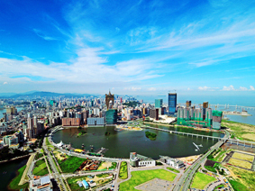
54. Land reclamation

In order to keep up with the accelerated pace of urban development, Macao has undertaken a series of major land renovation and reclamation projects. By expanding buildable area, it will be possible to provide the space necessary to improve the quality of life of the people of Macao.
Photo supplied by Macao SAR Government Information Bureau

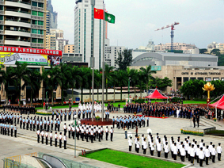
55. Celebrating with the motherland

October 1 is China's National Day, marking the founding of the People's Republic of China. Every year on this date, the Macao SAR Government raises the flags of China and Macao at Golden Lotus Square, in a grand celebration of the nation's birthday.
Photo supplied by Macao SAR Government Information Bureau

